Beer Bar Rental Contract
Client Information:
Name: __________________________ Phone: _________________Text ok? (circle) Yes or no
Email: ________________________________________________________________________________
Date needed: ___________________ Delivery time requested: _________________________
Venue name/address: _________________________________________________________________
Beer Vendor & Names of Beer/Cider: _________________________________________________
*NUBU in Santa Cruz is recommended 1030 41st Ave, SC CA 831-350-0253
Wedding Coordinator & Contact info:_______________________________________________
Terms:
-One Beer Bar will be rented, which includes the jockey box, and beer taps. This beer bar accommodates 2 taps, and can hold 2 full sized kegs or smaller. Deposit for value of unit will be required of $500.00, which will be returned in full as long as there is no damage to the unit**
- Deposit & payment for rental will be required in the form of a check or cash. $500.00 Deposit due one week prior to rental date. If using check, the check will not be deposited unless there is damage to the unit after rental.
-Beer Bar rental fee is $350, includes delivery w/décor as shown in attached picture. Beer bar does not include **ice, beer, CO2 Tank, and does not include keg attachment service*. Renter is responsible for those items. Cash, check, or credit cards are accepted forms of payment. (an additional 3.5% fee will be added for credit card payments).
**Customer will need up to 20lbs or less of ice per beer keg based upon beer keg size. Check with your caterer for ice. Beer vendor will specify amount of ice needed, and Beer Vendor will be able to provide: CO2 Tank, keg & keg delivery & keg attachment service. Karlas Kreations to provide beer keg ice tubs.
-A $50.00 non-refundable holding deposit is required at contract signing, to secure Beer Bar for your event date, and guarantees it will not be rented out elsewhere on that date. This fee will be deducted off final rental cost due one week prior to delivery.
-Beer bar will be delivered on date rented. Time will be arranged by Beer Bar owner and client, rental payment and deposit must be paid one week prior to rental date, but payments can be made prior. Bar will be picked up at event close time, or following date and deposit will be returned then as long as there is no damage to the unit and/or décor items missing**.
**If Beer Bar decoration items are not returned w/beer bar the cost of decorations will be deduced from Beer Bar deposit. (Assorted succulents $50.00, signs $45.00, ice tubs $4.00, hops garland-several varieties $150.00, beer taps/jockey box $300.00).
EQUIPMENT CARE
RESPONSIBILITY FOR ALL EQUIPMENT REMAINS WITH THE CUSTOMER FROM THE TIME OF DELIVERY TO THE TIME OF RETURN. Please safeguard the equipment and be sure it is protected and secured from the weather when not in use. (Do not leave out in the rain/fog). The client is solely responsible for any additional charges incurred as a result of failure to meet these conditions. Absolutely no nails or screws are allowed on/in the beer bar. Staples and push pins are accepted.

MISSING OR DAMAGED ITEMS
Karlas Kreations will pick-up the Beer Bar on a specified date agreed upon the contract. If not all items are present, it is the customers responsibility to return these items to Karlas Kreations within 24 hours after the event. Any items not returned within this time frame are considered missing. Missing or damaged items will be charged to the client at replacement cost as described in above, and will be deducted from the deposit. The security deposit will be returned once all items have been returned if not returned on pick up date/time.

I HAVE READ AND AGREE TO THE ABOVE TERMS & CONDITIONS AND ACKNOWLEDGE RECEIPT. THIS CONTRACT IS VALID FOR THE RENTALS PURCHASED BY THIS CLIENT.
Customer Signature: _________________________________Date: ______________ Contract#: _____________
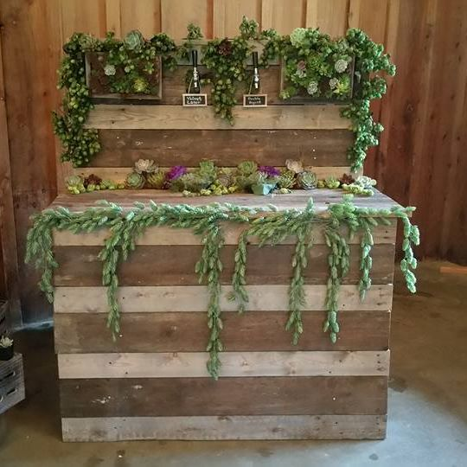

Malt is the soul of beer….. and yeast gives it life….. but the kiss of the hop is the vitality of that life!

