Beer Bar Rental Contract
Client Information:
Name: ___________________________ Phone: __________________ Text ok? (circle) Yes or no
Email: __________________________________________________________________________________
Date needed: ___________________ Delivery time requested: _________________________
Venue name/address: _________________________________________________________________
Beer Vendor & Names of Beer/Cider: _________________________________________________
*NUBU in Santa Cruz is recommended 1030 41st SC 831-350-0253
Wedding Coordinator & Contact info:_______________________________________________
Terms:
-One Beer Bar will be rented, which includes the jockey box , and beer taps. This beer bar accommodates 2 taps, and can hold 2 full sized kegs or smaller. Deposit for value of unit will be required of $500.00, which will be returned in full as long as there is no damage to the unit**
- Deposit and payment will be required in the form of a check, cash or credit card which will be due at date stipulated in floral proposal.
-Beer Bar rental fee is $200 **, includes delivery w/décor as shown in attached picture. Reduced from $350.00 to $200 w/full service floral package. Beer rental includes jockey box, 2 beer taps, and 2 ice tubs. (**Full service floral is florist providing all floral services for the event/wedding: ceremony, cocktail, reception, bridal party, ect).
Renter responsibility: Ice, beer, rental of CO2 Tank, and keg attachment service. (CO2 tank can be rented from Beer supplier.)
Cash, check, or credit cards are accepted forms of payment. (an additional charge of 3.5% will be added w/credit card payments).
** Customer will need approx. 20lbs per ice per keg of beer, or less dependent upon size of keg. Beer vendor will specify amount of ice needed, and customer can order from caterer. Beer vendor should provide keg delivery and keg attachment service. Karlas Kreations to provide 2 tubs for keg and ice to sit in.
-Beer bar will be delivered on date rented. Time will be arranged by Beer Bar owner and client, rental payment and deposit must be paid prior to delivery date as stipulated in floral contract. Bar will be picked up at event close time, or following date. Deposit will be returned then as long as there is no damage to the unit and/or any décor items are missing**.
**If Beer Bar decoration items are not returned w/beer bar the cost of decorations will be deduced from Beer Bar deposit. (Assorted succulents $50.00, Signs $45.00,hops garland-several varieties $150.00, ice tubs $45.00, beer taps/jockey box $300.00). **
EQUIPMENT CARE
RESPONSIBILITY FOR ALL EQUIPMENT REMAINS WITH THE CUSTOMER FROM THE TIME OF DELIVERY TO THE TIME OF RETURN. Please safeguard the equipment and be sure it is protected and secured from the weather when not in use. (Do not leave out in the rain/fog). The client is solely responsible for any additional charges incurred as a result of failure to meet these conditions. Absolutely no nails or screws are allowed on/in the beer bar. Staples and push pins are accepted.

MISSING OR DAMAGED ITEMS
Karlas Kreations will pick-up the Beer Bar on a specified date agreed upon the contract. If not all items are present, it is the customers responsibility to return these items to Karlas Kreations within 24 hours after the event. Any items not returned within this time frame are considered missing. Missing or damaged items will be charged to the client at replacement cost as described in above, and deducted from the deposit. The security deposit will be returned once all items have been returned if not returned on pick up date/time.

I HAVE READ AND AGREE TO THE ABOVE TERMS & CONDITIONS AND ACKNOWLEDGE RECEIPT. THIS CONTRACT IS VALID FOR THE RENTALS PURCHASED BY THIS CLIENT.
Customer Signature: _________________________________Date: ______________ Contract#: _____________
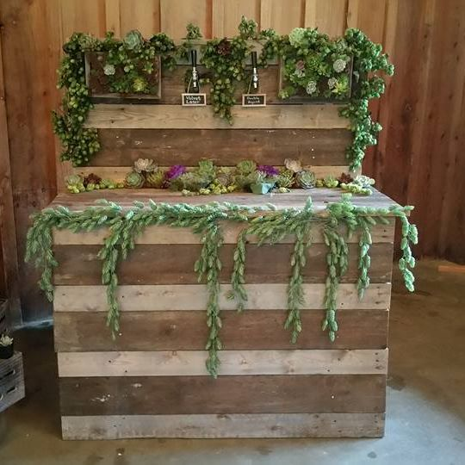
Malt is the soul of beer…..and yeast gives it life…..but the kiss of the hop is the vitality of that life!

